Experiment-11

Procedures

1. Create a table with attributes students and marks

Insert values into tables

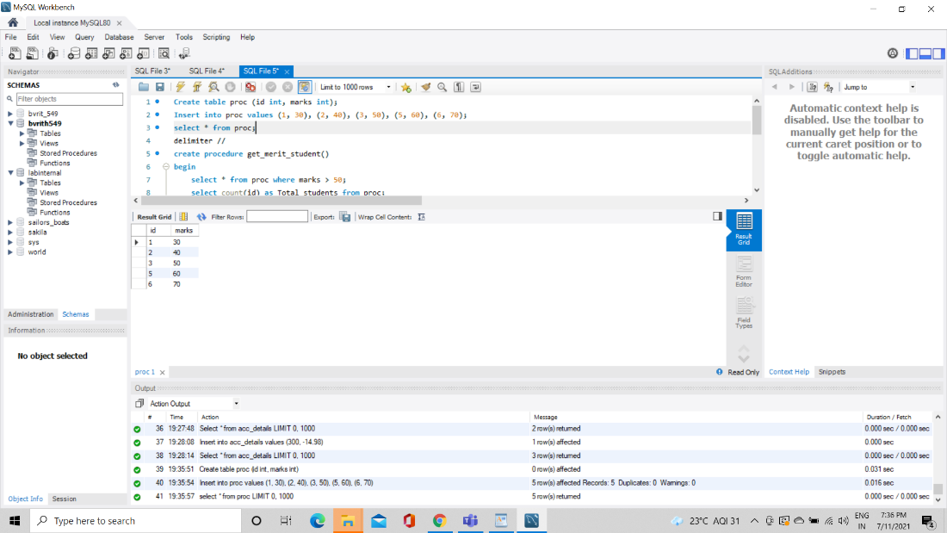

2. Create a procedure to get the merit students(marks>50)

3. Create a procedure to get marks of a given id(using in)

